Lincolnshire Fields Country Club – Equipment for sale
- 2012 Smithco Super Star Bunker Machine – 1900 hours on machine – new engine in 2018. Rear rake with brush, manual front plow. $ 5,000
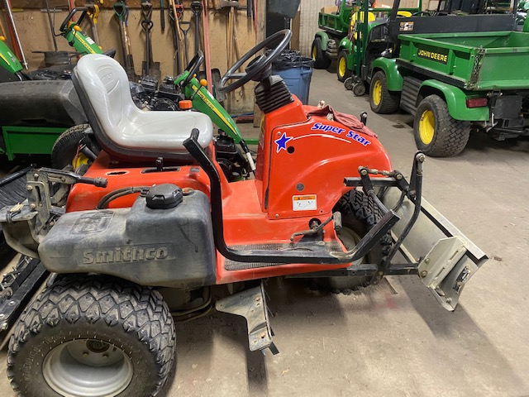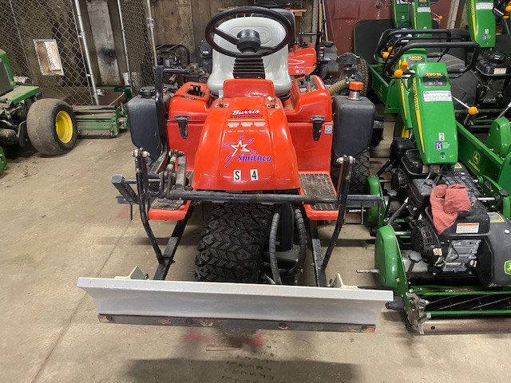
- 2003 Lely Spreader – Ground driven – good shape. $ 1,500
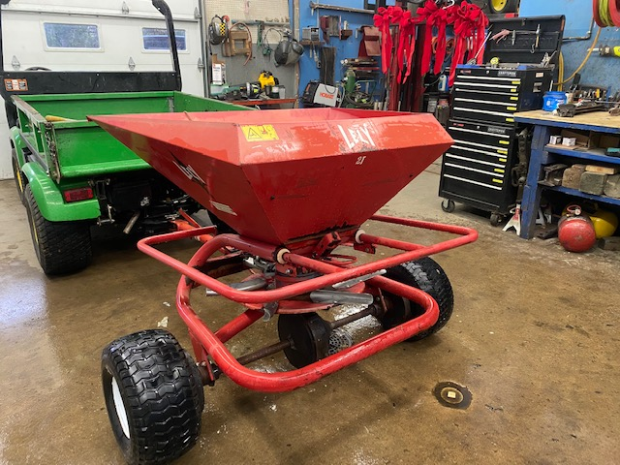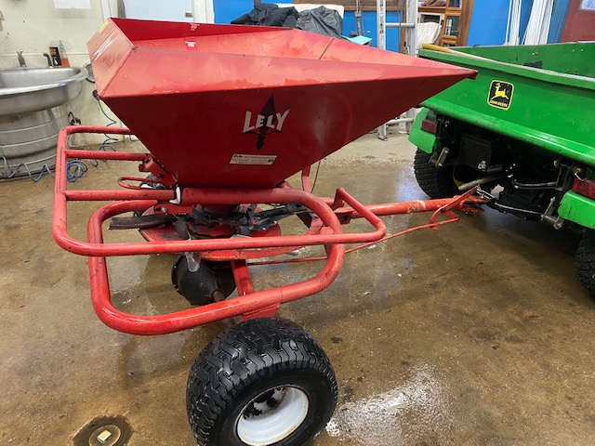
- 2010 3-gang Gandy Rollers – good shape. $ 1,500
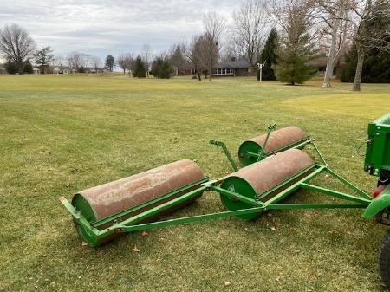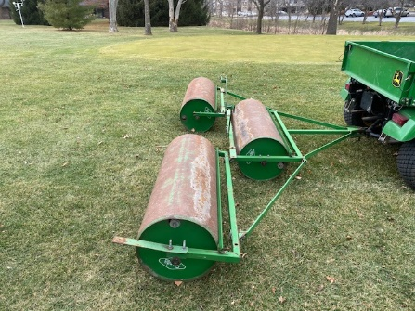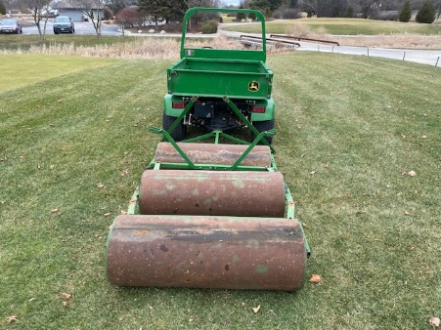

- 2002 True Surface Vibe Rollers – good shape. $ 2,000
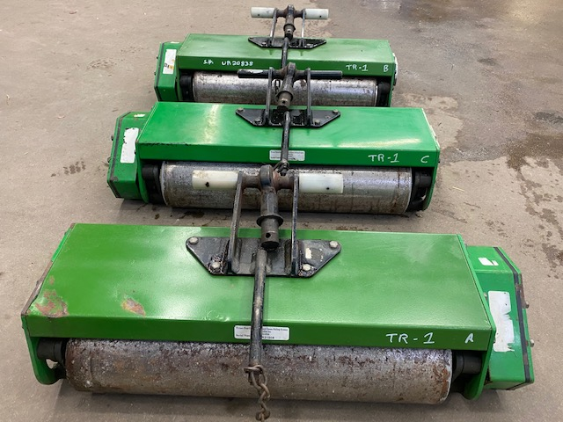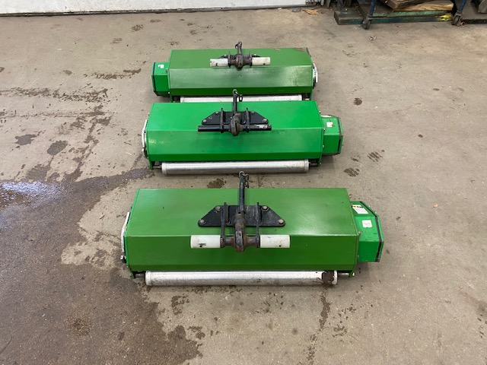
- 1995 RainBird Weather Station – in use till 2019. $ 1,000
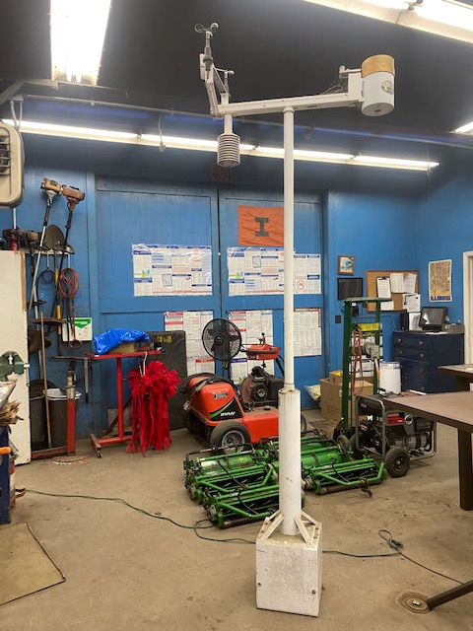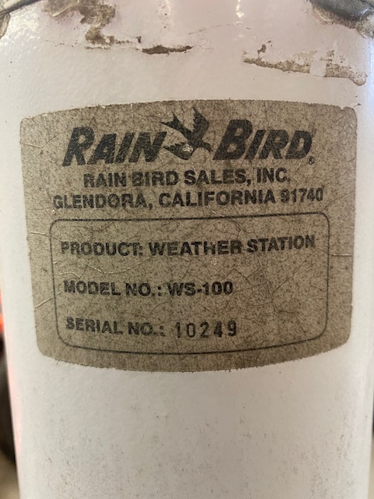
- RainBird Eagle 700 and 750 sprinklers. $ 25 ea.
- RainBird Quick Couplers $ 15 ea.
- Economy Valve Boxes $ 2 ea.
Please contact Scott Werner, Lincolnshire Fields C.C.
jswerner@usa.net
(217)493-9088

